Test Case: tc005_SPX_Dev5_Crear_Requisicion_Spot_Con_FAD_Tipo_Cobro_Project
Step 1 - Enter username and password and click to button Enter: Credentials Entered
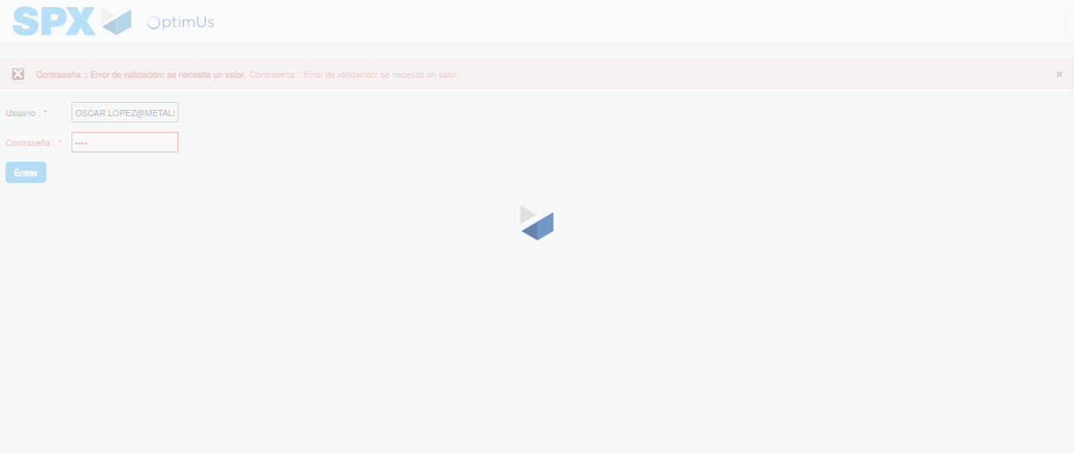Image file-name: QC_Testing-tc005_SPX_Dev5_Crear_Requisicion_Spot_Con_FAD_Tipo_Cobro_Project-1784571202246

Step 2 - Select to UEN and Access to Spot Buy Requisitions : UEN Correctly selected and Correct access
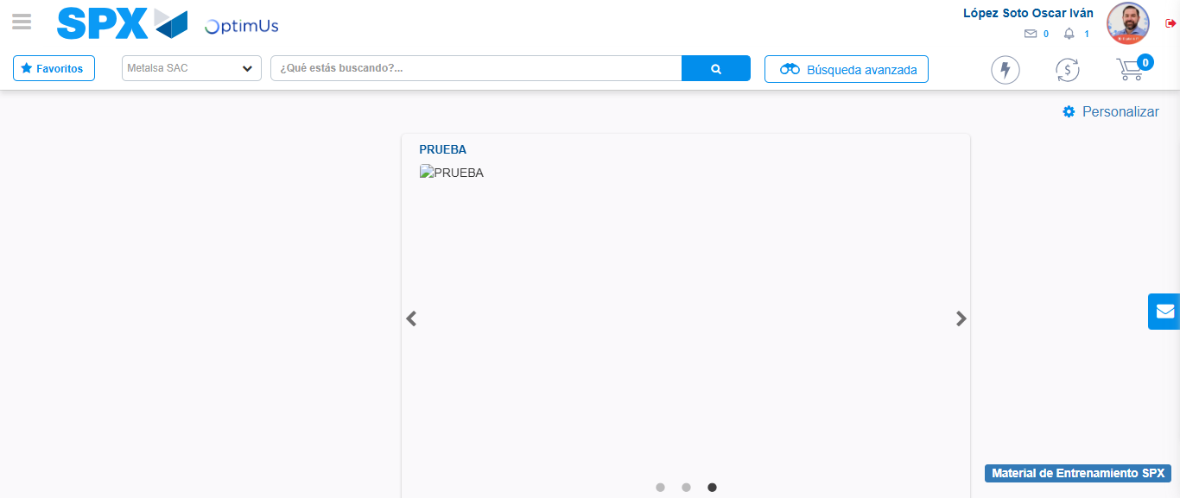Image file-name: QC_Testing-tc005_SPX_Dev5_Crear_Requisicion_Spot_Con_FAD_Tipo_Cobro_Project-1784571279128

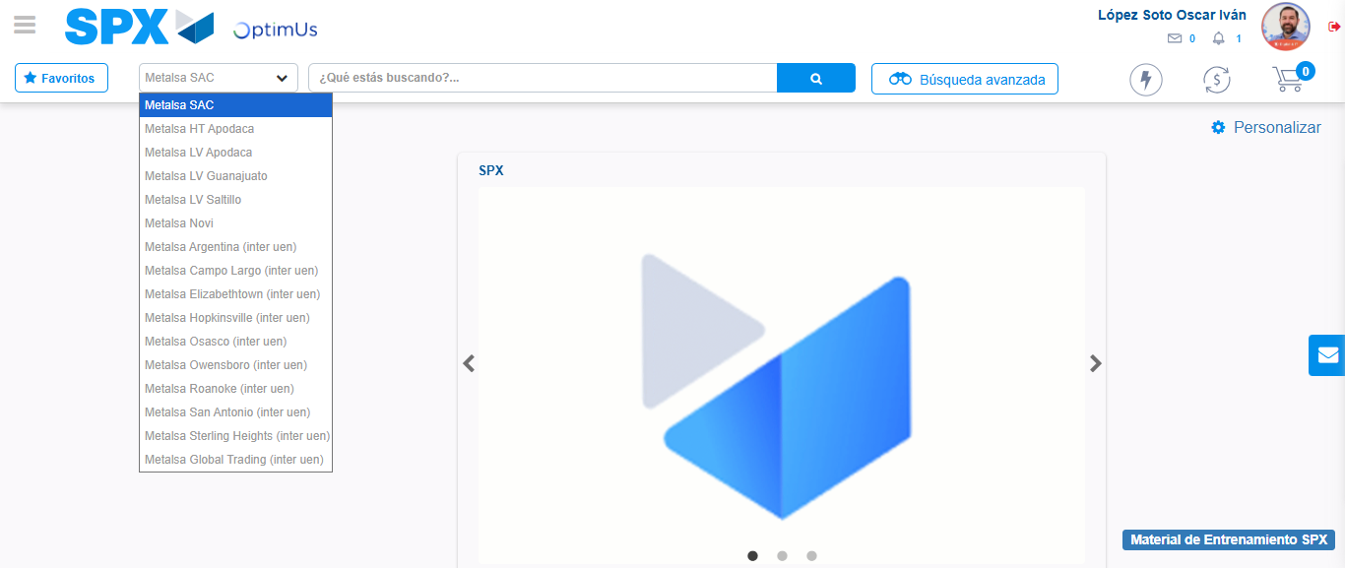Image file-name: QC_Testing-tc005_SPX_Dev5_Crear_Requisicion_Spot_Con_FAD_Tipo_Cobro_Project-1784571281918

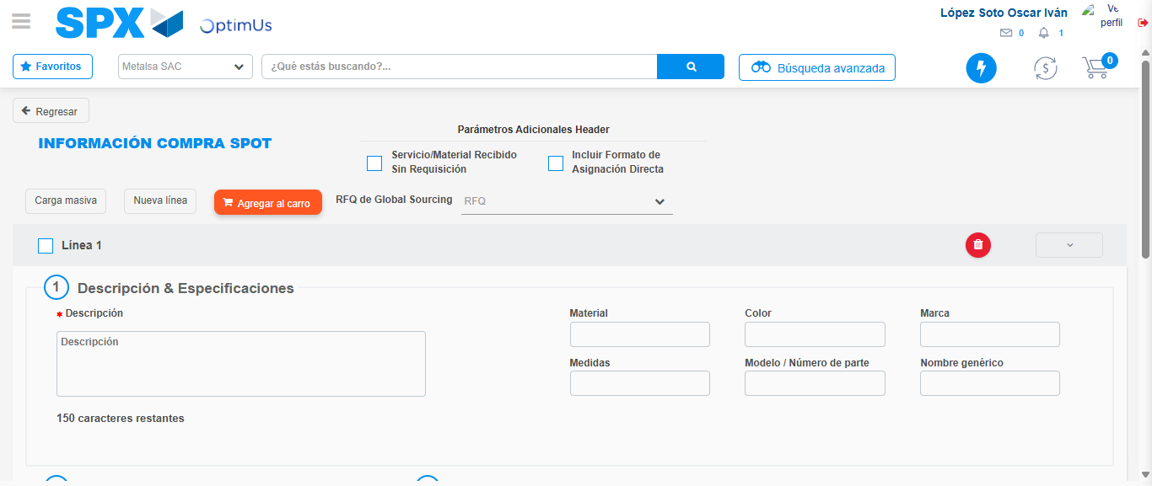Image file-name: QC_Testing-tc005_SPX_Dev5_Crear_Requisicion_Spot_Con_FAD_Tipo_Cobro_Project-1784571298347

Step 3 - Add FAD to Requisition: FAD Successfully Added
Image file-name: QC_Testing-tc005_SPX_Dev5_Crear_Requisicion_Spot_Con_FAD_Tipo_Cobro_Project-1784571298646

Image file-name: QC_Testing-tc005_SPX_Dev5_Crear_Requisicion_Spot_Con_FAD_Tipo_Cobro_Project-1784571298855

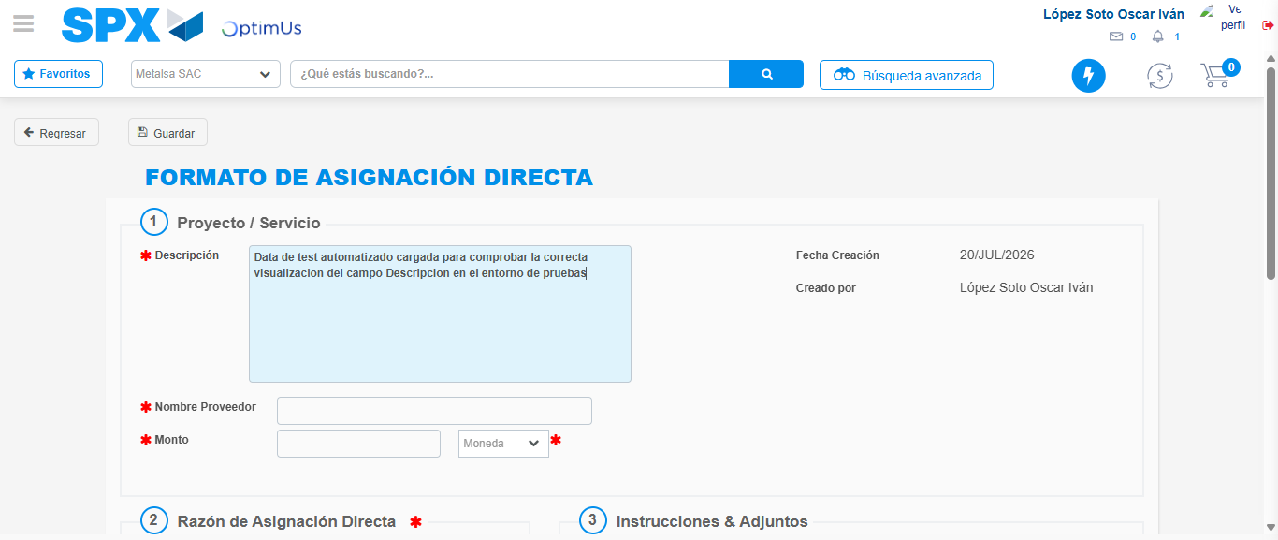Image file-name: QC_Testing-tc005_SPX_Dev5_Crear_Requisicion_Spot_Con_FAD_Tipo_Cobro_Project-1784571301949

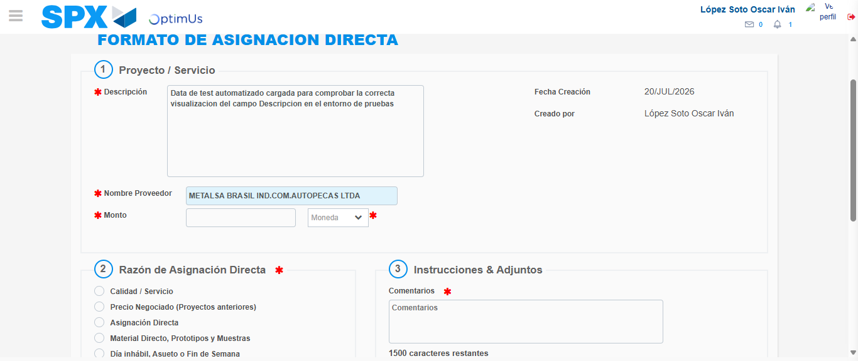Image file-name: QC_Testing-tc005_SPX_Dev5_Crear_Requisicion_Spot_Con_FAD_Tipo_Cobro_Project-1784571309019

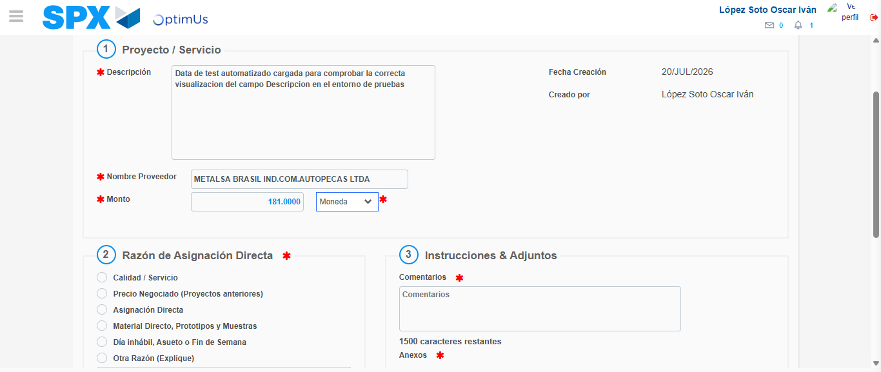Image file-name: QC_Testing-tc005_SPX_Dev5_Crear_Requisicion_Spot_Con_FAD_Tipo_Cobro_Project-1784571309462

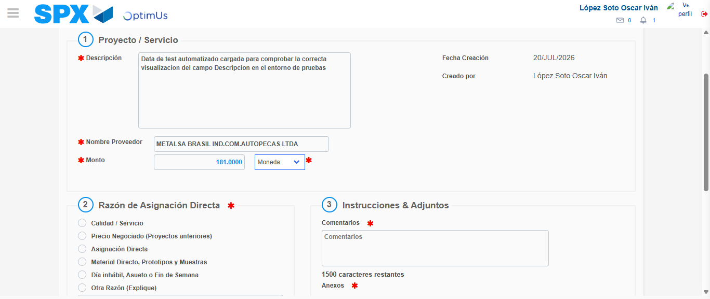Image file-name: QC_Testing-tc005_SPX_Dev5_Crear_Requisicion_Spot_Con_FAD_Tipo_Cobro_Project-1784571309743

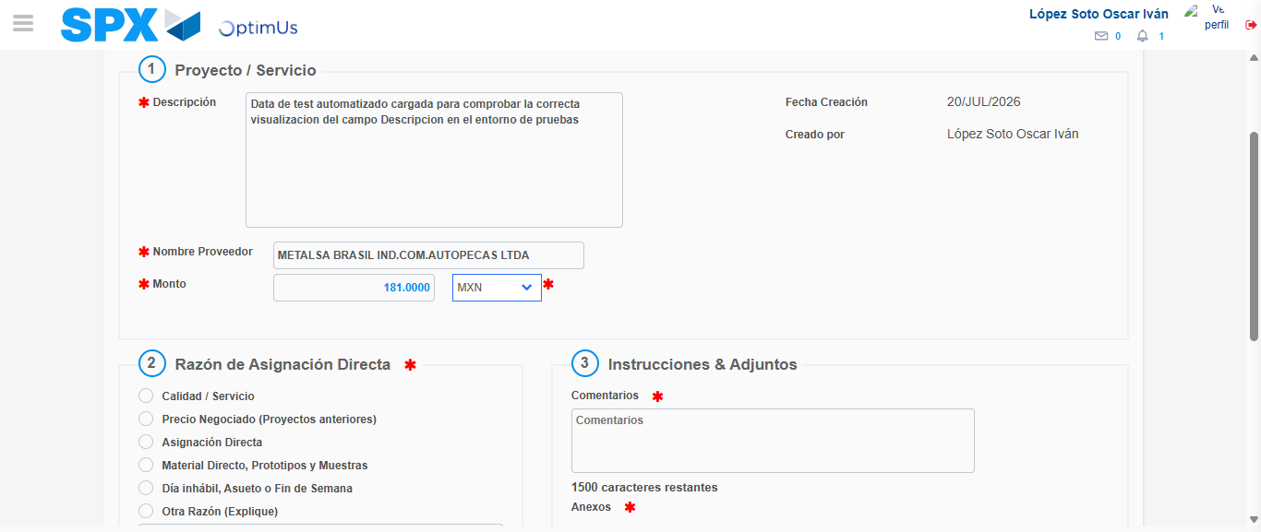Image file-name: QC_Testing-tc005_SPX_Dev5_Crear_Requisicion_Spot_Con_FAD_Tipo_Cobro_Project-1784571310264

Image file-name: QC_Testing-tc005_SPX_Dev5_Crear_Requisicion_Spot_Con_FAD_Tipo_Cobro_Project-1784571310542

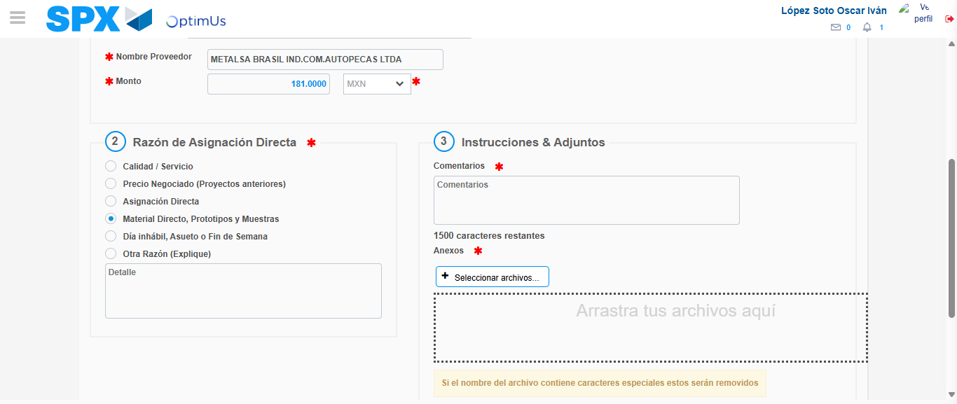Image file-name: QC_Testing-tc005_SPX_Dev5_Crear_Requisicion_Spot_Con_FAD_Tipo_Cobro_Project-1784571311531

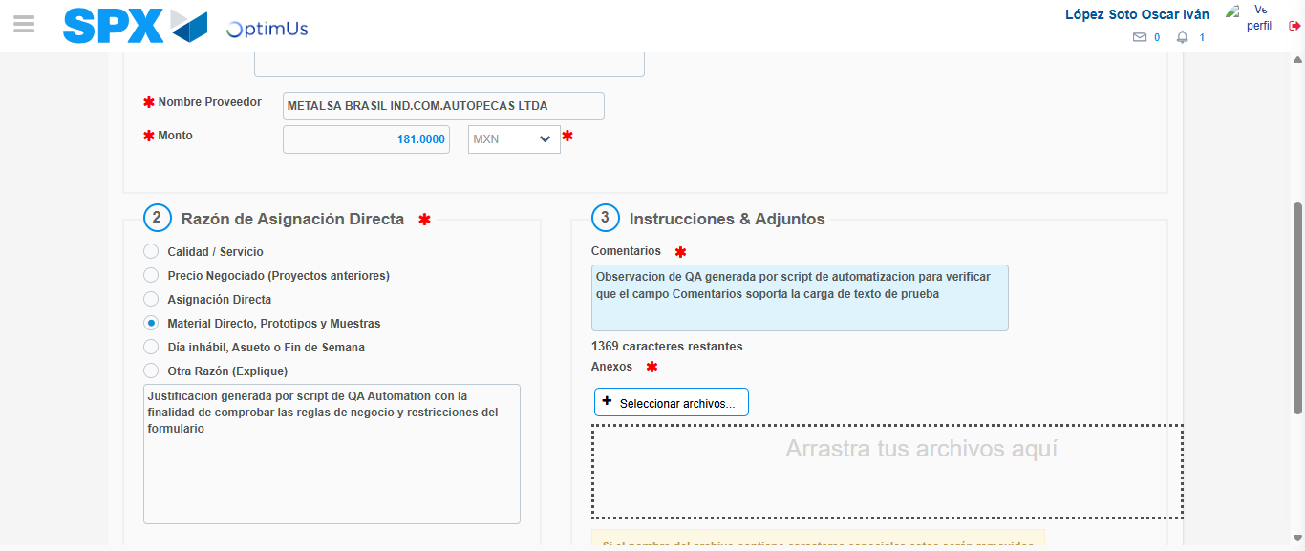Image file-name: QC_Testing-tc005_SPX_Dev5_Crear_Requisicion_Spot_Con_FAD_Tipo_Cobro_Project-1784571322945

Image file-name: QC_Testing-tc005_SPX_Dev5_Crear_Requisicion_Spot_Con_FAD_Tipo_Cobro_Project-1784571323817

Step 4 - Data Capture Spot Buy Requisition: Data captured correctly
Image file-name: QC_Testing-tc005_SPX_Dev5_Crear_Requisicion_Spot_Con_FAD_Tipo_Cobro_Project-1784571298646

Image file-name: QC_Testing-tc005_SPX_Dev5_Crear_Requisicion_Spot_Con_FAD_Tipo_Cobro_Project-1784571298855

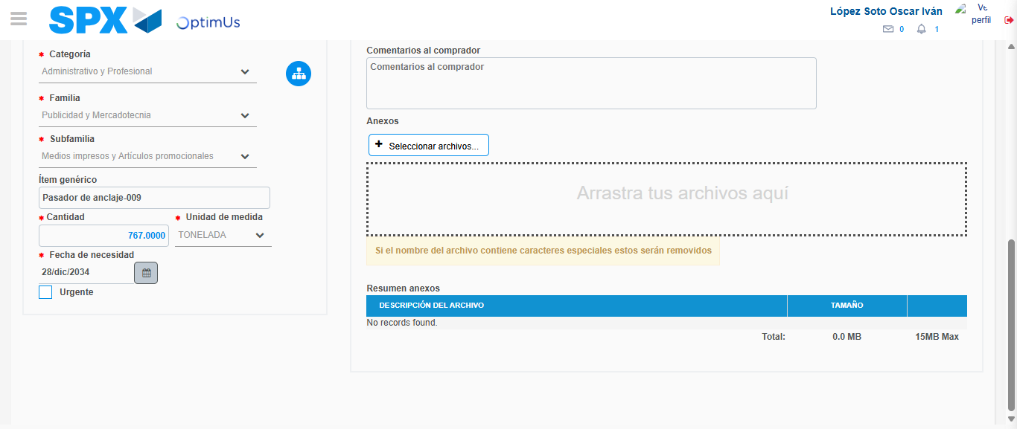Image file-name: QC_Testing-tc005_SPX_Dev5_Crear_Requisicion_Spot_Con_FAD_Tipo_Cobro_Project-1784571338405

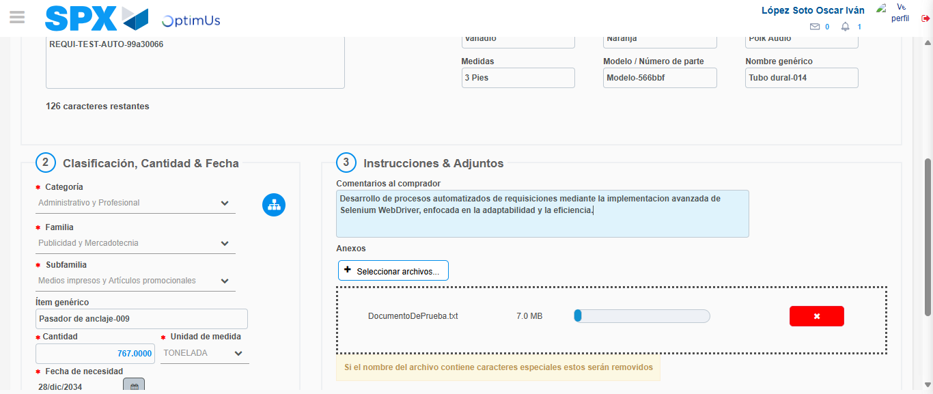Image file-name: QC_Testing-tc005_SPX_Dev5_Crear_Requisicion_Spot_Con_FAD_Tipo_Cobro_Project-1784571339184

Step 8 - Return to Main Page SPX : Return to Main Page SPX
Image file-name: QC_Testing-tc005_SPX_Dev5_Crear_Requisicion_Spot_Con_FAD_Tipo_Cobro_Project-1784571279128

Image file-name: QC_Testing-tc005_SPX_Dev5_Crear_Requisicion_Spot_Con_FAD_Tipo_Cobro_Project-1784571281918

Image file-name: QC_Testing-tc005_SPX_Dev5_Crear_Requisicion_Spot_Con_FAD_Tipo_Cobro_Project-1784571298347

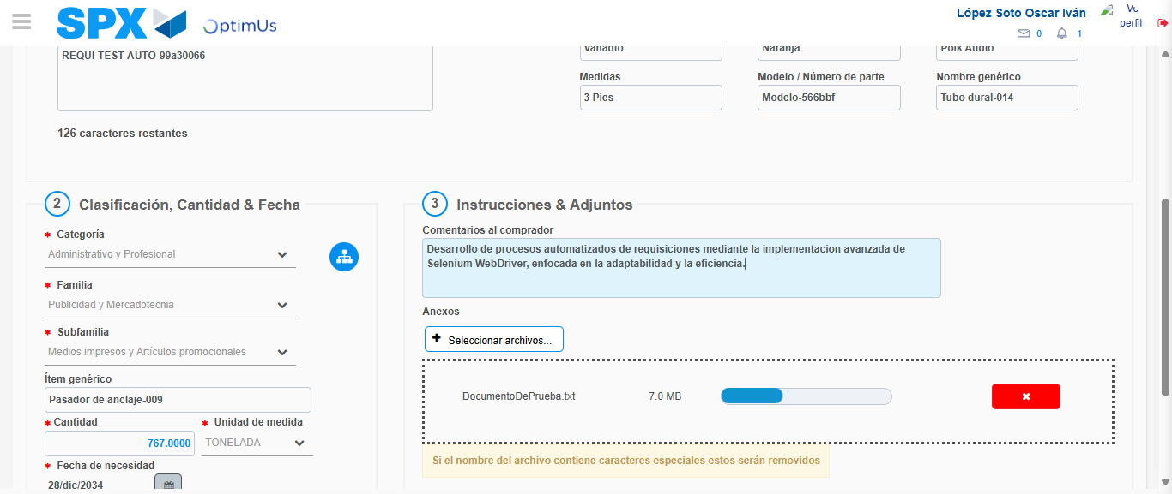Image file-name: QC_Testing-tc005_SPX_Dev5_Crear_Requisicion_Spot_Con_FAD_Tipo_Cobro_Project-1784571341405

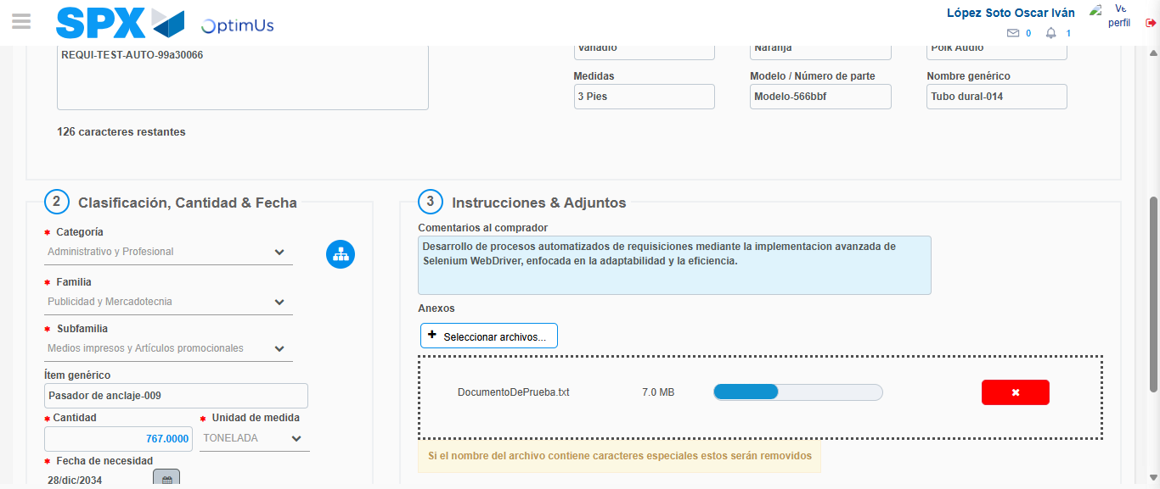Image file-name: QC_Testing-tc005_SPX_Dev5_Crear_Requisicion_Spot_Con_FAD_Tipo_Cobro_Project-1784571341577

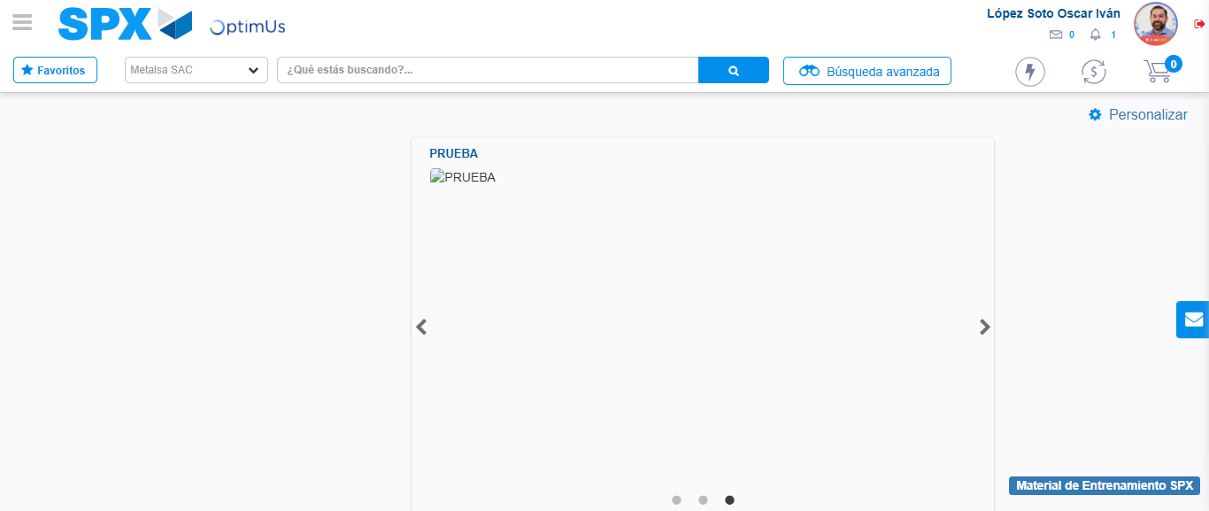Image file-name: QC_Testing-tc005_SPX_Dev5_Crear_Requisicion_Spot_Con_FAD_Tipo_Cobro_Project-1784571362553

Step 9 - Log Out : Log Out SPX
Image file-name: QC_Testing-tc005_SPX_Dev5_Crear_Requisicion_Spot_Con_FAD_Tipo_Cobro_Project-1784571362746

